Michael Chan

Accuracies for N=30 and C=10

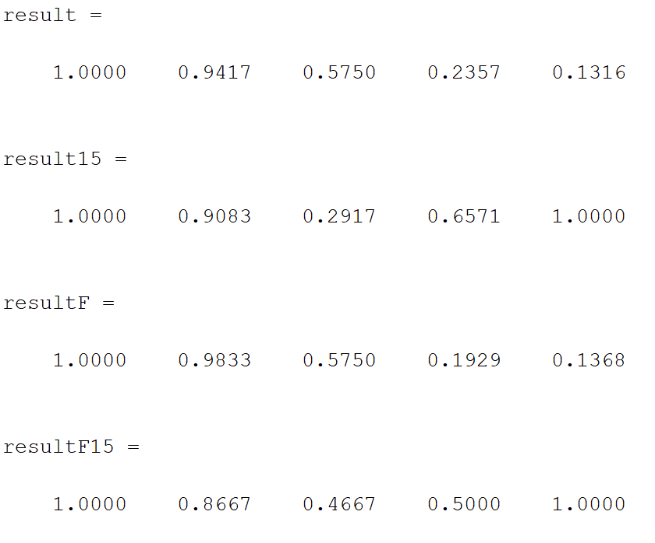

|  |  |  |  |  |  |
| --- | --- | --- | --- | --- | --- |
|  | Set 1 Accuracy | Set 2 Accuracy | Set 3 Accuracy | Set 4 Accuracy | Set 5 Accuracy |
| Eigenfaces trained on subset 1  N=30 | 1.00 | 0.9417 | 0.5750 | 0.2357 | 0.1316 |
| Eigenfaces trained on subset 1 and 5  N=30 | 1.00 | 0.9083 | 0.2917 | 0.6571 | 1.00 |
| Fisherfaces trained on subset 1  C=10 | 1.00 | 0.9833 | 0.5750 | 0.1929 | 0.1368 |
| Fisherfaces trained on subset 1 and 5  C=10 | 1.00 | 0.8667 | 0.4667 | 0.50 | 1.00 |

Error Rates for N=30 and C=10

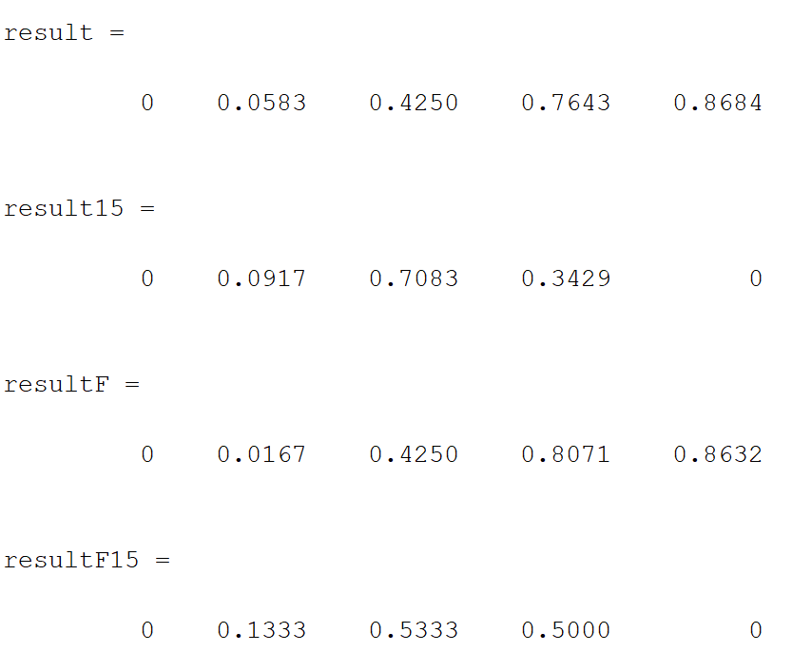

|  |  |  |  |  |  |
| --- | --- | --- | --- | --- | --- |
|  | Set 1 Error | Set 2 Error | Set 3 Error | Set 4 Error | Set 5 Error |
| Eigenfaces trained on subset 1  N = 30 | 0 | 0.0583 | 0.4250 | 0.7643 | 0.8684 |
| Eigenfaces trained on subset 1 and 5  N = 30 | 0 | 0.0917 | 0.7083 | 0..8071 | 0 |
| Fisherfaces trained on subset 1  C= 10 | 0 | 0.0167 | 0.4250 | 0.8071 | 0.1368 |
| Fisherfaces trained on subset 1 and 5  C = 10 | 0 | 0.1333 | 0.5333 | 0.500 | 0 |

Accuracies for N=9 and C=31

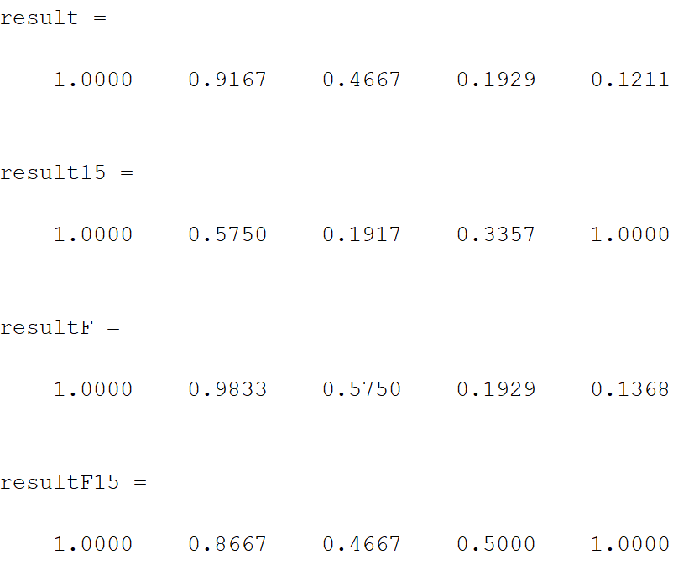

|  |  |  |  |  |  |
| --- | --- | --- | --- | --- | --- |
|  | Set 1 Accuracy | Set 2 Accuracy | Set 3 Accuracy | Set 4 Accuracy | Set 5 Accuracy |
| Eigenfaces trained on subset 1  N = 9 | 1.0 | 0.9167 | 0.4667 | 0.1929 | 0.1211 |
| Eigenfaces trained on subset 1 and 5  N = 9 | 1.0 | 0.5750 | 0.1917 | 0.3357 | 1.0 |
| Fisherfaces trained on subset 1  C= 31 | 1.0 | 0.9833 | 0.5750 | 0.1929 | 0.1368 |
| Fisherfaces trained on subset 1 and 5  C = 31 | 1.0 | 0.8667 | 0.4667 | 0.5 | 1.0 |

Error Rate for N=9 and C=31

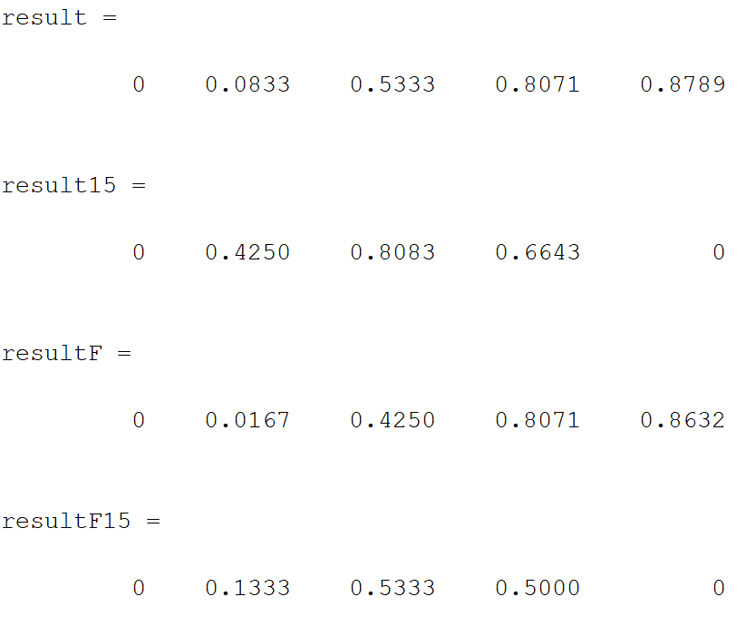

|  |  |  |  |  |  |
| --- | --- | --- | --- | --- | --- |
|  | Set 1 Error | Set 2 Error | Set 3 Error | Set 4 Error | Set 5 Error |
| Eigenfaces trained on subset 1  N = 9 | 0 | 0.0833 | 0.5333 | 0.8071 | 0.8789 |
| Eigenfaces trained on subset 1 and 5  N = 9 | 0 | 0.4250 | 0.8083 | 0.6643 | 0 |
| Fisherfaces trained on subset 1  C= 31 | 0 | 0.0167 | 0.4250 | 0.8071 | 0.8632 |
| Fisherfaces trained on subset 1 and 5  C = 31 | 0 | 0.1333 | 0.5333 | 0.500 | 0 |

**Eigenface Algorithm**

1. Find mean face
$$uj= \frac{1}{n}*∑(subset)$$

2. Subtract mean from each column of subset
$$x= subset\left(i\right)-uj$$

3. Now that data is preprocessed, solve for eigenvectors of the preprocessed data.
$$\left[U,S,V\right]=svd(x)$$

4. Now that we have the largest eigenvectors of the data, reduce it to k eigenvectors.
$$ureduce=U(:,1:k)$$

5. We now have our the top eigenfaces for the subset, to project it onto our eigenspace w, we use the equation
$$w{}_{train}= ureduce^{'}*x$$

6. We can then apply the ureduce to any new subset x to test on
$$w_{test}=ureduce^{'}*x_{test}$$

7. Then we compare the training eigenspace and the test eigenspace against each other using nearest neighbors algorithm.

**Top 9 Eigenvectors after training on subset 1**

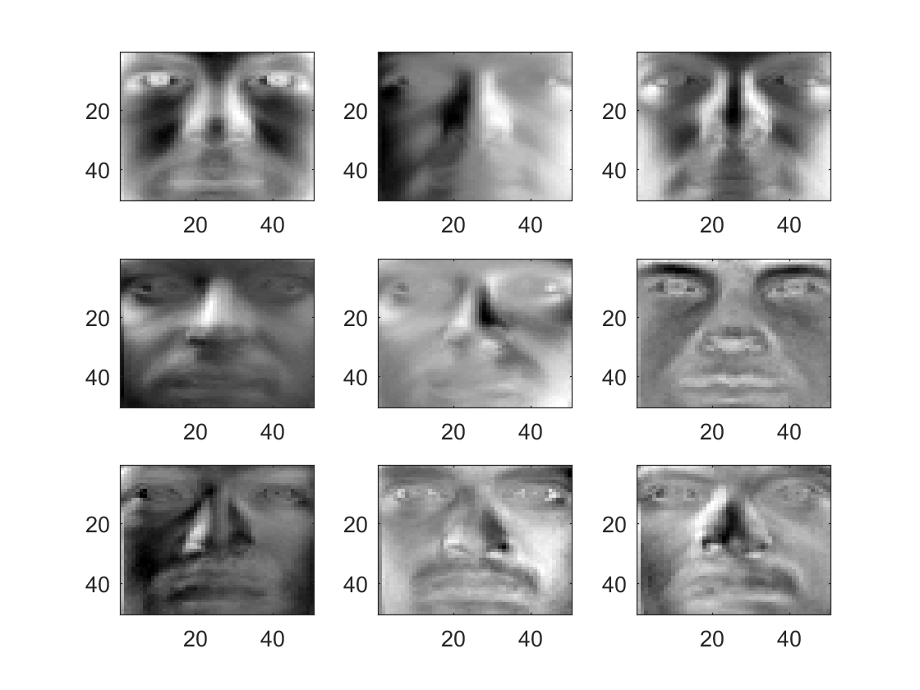

**Reconstructed Eigenfaces**

D = 9

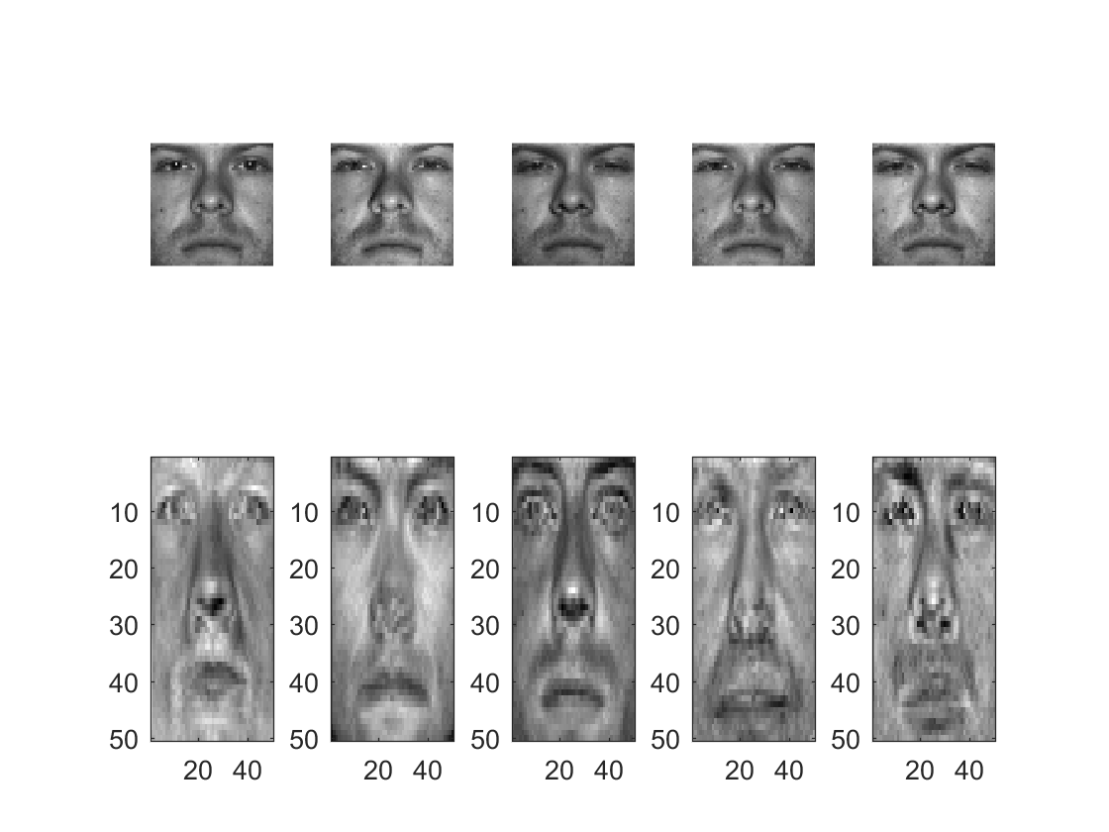

D = 30

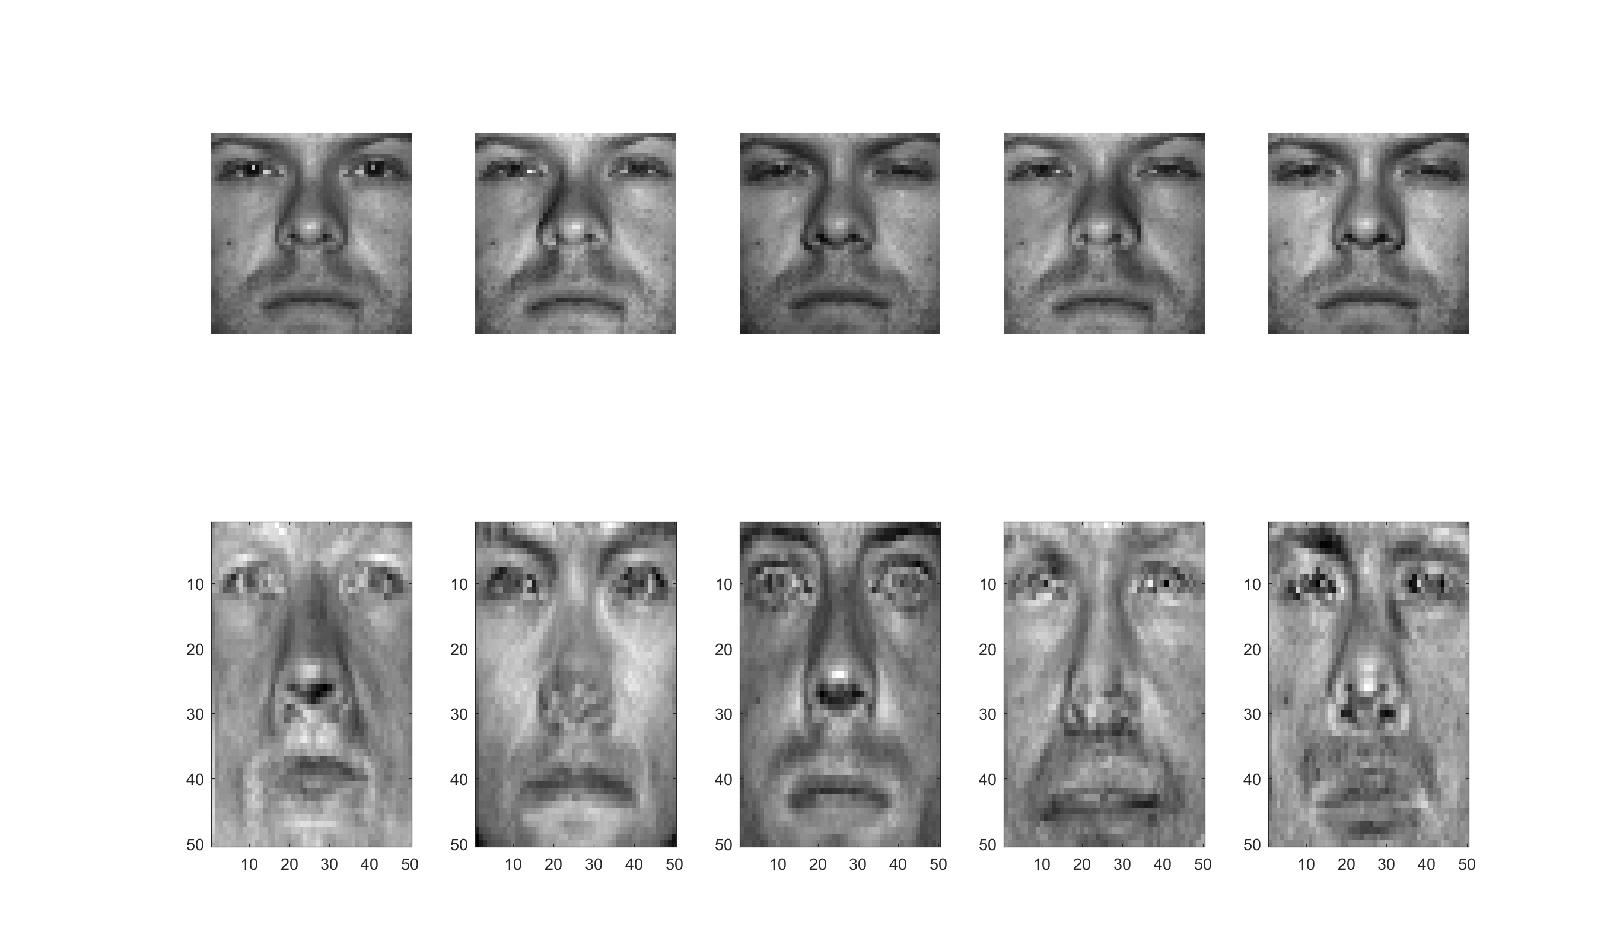

**Fisherfaces Algorithm**

1. Do the eigenface algorithm as shown above. We ended with our eigenspace w.
$$w{}_{train}= ureduce^{'}*x$$

2. FLD requires us to calculate the different scatters of the data. First, we calculate the scatter of each individual class.

$$S_{i}=∑\left(x_{k}-u_{i}\right)*\left(x_{k}-u_{i}\right)'$$

Where $u_{i}$ = the local mean of the class i and $x_{k}$ is the subset for class i.

1. Now that we have the scatter of each individual class, we can then calculate for the within class scatter using the equation
$$S_{w}=∑S_{i}$$

2. In addition to this, we also need to calculate our between class scatter, which requires the mean of the whole dataset.
$$S_{b}= ∑N_{i}(u_{i}-u)(u_{i}-u)'$$

3. Now that we have Sw and Sb, we then solve the generalize eigenvector problem associated through the use of Sw and Sb.
$$\left[V,D,W_{fld}\right]=eig(Sb,Sw)$$

4. Now that we have the FLD of the data, we can now compute Wopt by applying our FLD to our PCA.

$$W_{opt}^{'}=W_{fld}'*ureduce$$

**Extra:**

**Accuracies when cutting out the top 3 eigenvectors for Eigenfaces**

